
Floor Plan Symbols Handout

Introduction
One of the most important responsibilities of a design professional is to document the design with construction drawings. It is imperative that the drawings incorporate symbols, notes, and dimensions in a careful and consistent manner so the plan is uncluttered, easy to read, and understandable to everyone involved in the project design and construction. The design and construction industry has developed standard symbols to represent common building components. You should use these standard symbols in your sketches so that other professionals will understand your intended design.

Using the appropriate symbols for the living space, including symbols for doors, windows, cabinets, appliances, and plumbing fixtures; and those more closely associated with the construction of the structure, including electrical circuits, material description and sizing, and proper dimensioning, provides for the creation of a floor plan that is easy to read and also easy to build.

A good source for information about standard products and their appropriate costs is the Sweet’s catalogs (www.sweets.com). These catalogs are available to browse for ideas and information needed to find particular products. Manufacturer’s websites and literature are also helpful.

The following table provides standard architectural symbols for some of the most common residential components and features. Use the symbols provided here to sketch floor plans for your Affordable Housing Project in the next activity. Remember that your selections must follow the Habitat philosophy of cost-effective materials and components.

Architectural Symbols
Component | Symbol | Common Size
Door |  | 2” increments in width  6’-8” or 7’-0” height
Sliding door |  | 5’-0”, 6’-0” or 7’-0” wide  6’-8” or 7’-0” height
Bifold door |  | 2” increments in width  6’-8” or 7’-0” height
Pocket door |  | 2” increments in width  6’-8” or 7’-0” height
Fixed window |  | 2” increments in width and height
Casement window |  | 2” increments in width  and height
Double hung window |  | 2” increments in width  and height
Refrigerator | 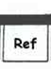 | 36 in. W x 27 in. D
Stove | 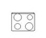 | 30” in. x 24 in. D
Dishwasher | 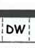 | 24 in. x 24 in.
Washing machine | 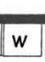 | 27 in. W x 24 in. D
Dryer | 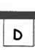 | 27 in. W x 24 in. D

Component | Symbol | Typical Size
Water heater | 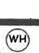 | 18 in. – 22 in. diameter
Skylight | 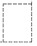
Stairs | 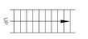
Bath tub |  | 32 in. x 60 in.
Shower | 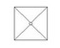 | 36 in. or 42 in. square
Water closet | 
Vanity and sink | 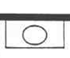
Kitchen sink | 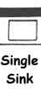
Cabinets | 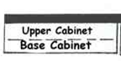 | Base: 24” D  Upper: 12” D
Closet shelf and rod | 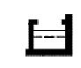 | Minimum 2’-0” closet depth

